**INFLATION AND ECONOMIC GROWTH OF EMERGING ECONOMIES IN SUB-SAHARAN AFRICA**

**A DSM 2022 BOOTCAMP CAPSTONE REPORT**

**COMPILED BY:**

**OBIOMA OGBUOKIRI**

**EMEKA ONYEJIZU**

**LANRE ALABA**

**AMINAT ODEDEYI**

**JOSHUA OGUNSOLA**

**SAMUEL BLESSING OLUGBADE**

**ADENIKE APATA**

**NOVEMBER, 2022**

## TABLE OF CONTENTS

ABSTRACT ………………………………………………………………………………………………………….… 3

CHAPTER ONE: INTRODUCTION AND LITERATURE REVIEW …………………………….… 5

CHAPTER TWO: METHODOLOGY …………………………………………………………………….... 8

CHAPTER THREE: RESULTS …………………………………………………………………………………. 12

CHAPTER FOUR: DISCUSSION AND CONCLUSION ……………………………………………….19

REFERENCES …………………………………………………………………………………………………………… 21

APPENDIX ………………………………………………………………………………………………………………. 22

### ABSTRACT

Sub-Saharan Africa is a region comprising the African countries south of the Sahara. More than 800 million people are living in Sub-Saharan Africa, which includes 48 countries. In 2025, the region's GDP growth was projected by the IMF to reach 6.6%. That meant that sub-Saharan Africa is developing faster than Asia if you factor out China and India.

Inflation in Africa, with the remarkable exception of Zimbabwe, is substantially under control. Although Africa is ravaged by poverty and is trailing behind in development and technology, recent studies showed that the global economic crisis has brought to light Africa's stance as the next large market with the potential for explosive development in the upcoming years. The IMF's upgrade of many countries in the region, including Botswana, Ghana, Kenya, Mozambique, Nigeria, Tanzania, Uganda, and Zambia, to the category of "emerging markets" is another indicator of the region's growth. Asides from GDP growth, emerging markets have characteristics of an increasing per capita income, increased debts, and market liquidity. It is worthy of note that one of the economic risks faced by emerging markets is high inflation.

Inflation is a measure of the rate of rising prices of goods and services in an economy. If inflation is occurring, leading to higher prices for necessities such as food, it can harm society. While a high inflation rate tends to spiral out of control and harm the economy's long-term performance, a low but positive inflation rate is economically advantageous.

In this study, descriptive analysis, to determine the trend of both inflation rate and economic growth, was done on the inflation and GDP data of the sub-Saharan African countries obtained from www.kaggle.com. Beforehand, the data obtained were cleaned and prepared for analysis. The country with the lowest average inflation rate and GDP was found as well as the countries with the highest average inflation rate and GDP over the period of study.

Comparative analysis was done to ascertain the relationship between the inflation rate and growth over this region within the period of study and a model was developed to project the future inflation rate over this region given the economic growth, focusing on the emerging economies.

### INTRODUCTION AND LITERATURE REVIEW

#### 1.0 INTRODUCTION

Africa's sub-Saharan region is one of the six major geographical areas in the world comprising 49 countries. During the period that some experts refer to as "Africa Rising" in the early 2000s, this region saw significant economic growth and investment. The IMF predicted that the region's GDP growth would reach 6.6% in 2025. In other words, if China and India are taken out of the equation, sub-Saharan Africa is developing more quickly than Asia. Despite this increase in income, inequality has not decreased and neither have average salaries nor the number of jobs increased in the region. This growth was halted by the global financial crisis of 2008 and a drop in the price of essential commodities like crude oil, iron ore, copper, and palm oil. Additionally, there are persistent problems in the area, including inadequate infrastructure and access to capital, which continue to restrain economic expansion. The region's economy was hampered by the legacy of colonialism, violence, unpredictability, and poor governmental leadership.

Gross Domestic Product (GDP) growth rate gauges the national income and output of a country's economy and estimates overall expenditure for the final worth of the services and articles produced within a certain period in a country (Abdullah et al, 2022). The lowest total gross domestic product (GDP), which is a measure of all goods and services generated in a nation or region, is found in Sub-Saharan Africa (SSA). Just under $4,000, or one-fifth of the global average, is its average GDP per capita (GDP divided by population). But in the future, this difference might close. In 2018, the area was home to eight of the twenty economies with the fastest growth rates worldwide. Despite significant GDP growth in nations like Ethiopia and Ghana, income in the sub-Saharan region is still highly concentrated. Nearly half of the region's GDP is produced by Nigeria and South Africa, the two richest nations in the continent.

This region, like other parts of the world, in recent times has experienced a rise in inflation rate which may likely affect the economic growth of the countries in the region. An important indicator of economic growth is GDP growth, and inflation is a risk associated with a growing economy. Inflation occurs when there is an increase in the price of goods and services which is persistent and above the specified benchmark. An increase in the money supply can gravitate to a higher price level in a matter of time. There are various types of inflation known in the literature, some of these types are: demand-pull, which arises as a result of an increase in aggregate demand without a corresponding increase in supply, supply push or cost-push inflation happens when a reduction in supply caused by an increase in the cost/price of the commodity produced (Anochiwa & Maduka, 2015). It can also be structural inflation, which arises as a result of changes in monetary policy. This type of inflation is generally referred to as built-in inflation. Within these categories, inflation can be hyper, extremely high, chronic, high, moderate, or low inflation (Umaru & Zubairu, 2012).

High inflation makes investments unworkable because future unsureness is generated, and because exports are becoming pricey, the balance of payments could influence. Rising inflation affects purchasing power and expected inflation may also drive consumers to spend more. Increasing inflation will reduce the buying capacity of cash, lower consumption, and lower GDP. A favourable correlation between inflation and GDP is seen in conflicting studies focused on emerging countries while a negative correlation between inflation and GDP is shown in various study projects undertaken for industrial and developed countries (Kearny and Chowdhury, 1997). However, multiple studies show that there can also be a beneficial correlation (Mamo, 2012).

#### 1.1 AIMS AND OBJECTIVES

* This study seeks to investigate how and to what extent inflation affects or influences economic growth in Sub-Saharan Africa.
* To determine the countries with the lowest average inflation rate and GDP.
* To determine the countries with the highest average inflation rate and GDP.
* To ascertain the relationship between the inflation rate and GDP growth in this region.

#### 1.2 LITERATURE REVIEW

Most nations around the world are primarily concerned with inflation and economic expansion. Different findings emerged from studies on the connection between inflation and economic expansion. According to Sarel (1997), inflation only has an impact on growth if it exceeds a certain "threshold" inflation rate. He concludes that the inflation threshold of around 8% for an aggregated sample of numerous nations serves as an excellent standard benchmark for the sample as a whole. A study by Kearny and Chowdhury (1997) showed no causality correlation between inflation and economic growth in 40% of the countries, bidirectional causality in about 20% of countries, and a unidirectional relationship between countries. For industrialized and developed nations, the connection between inflation and economic growth was examined, and the results revealed a negative correlation. On the other hand, inflation and economic growth were found to be positively correlated in developing nations. When inflation is low, there is a positive correlation between economic growth and inflation, but this link becomes negative when inflation is high, according to Ghosh and Phillips' 1998 study of 145 nations. Mamo (2012) investigated the impact of inflation on economic growth in 13 SSA nations between 1969 and 2009. The study uses panel regression to analyze factors like inflation, investment, population, and GDP. The research demonstrates an adverse relationship between inflation and economic growth, while the Granger causality shows that it is possible to forecast the growth rate among nations using the country's inflation rate.

### METHODOLOGY

#### 2.1 ACQUISITION OF DATA AND ITS DESCRIPTION

The datasets used are structured data on inflation rates (% annual) and GDP growth rates of the 48 Sub-Saharan African countries from 1960 to 2021. The datasets which originated from the World bank were obtained from kaggle.com. The dataset provided the information required to check and compare inflation rates across SSA countries over the years and then compare the inflation rate with GDP growth and check for patterns and trends over the years of consideration in this study. The data acquired was ideal for descriptive analysis such as investigating average inflation rates, top countries with the highest GDP growths, in this study, over the years and checking for insights on how it affects inflation rates.

#### 2.2 MANIPULATION AND DATA VISUALIZATION

#### 2.2.1 TOOLS FOR ANALYSIS

Python was used for programming the data cleaning and analysis. For this project, our preferred working environment was the Jupyter notebook. The datasets were cleaned and analyzed using a variety of Python tools and modules, including NumPy, pandas, matplotlib, SciPy, etc., that are needed for the analysis. Using these Python tools and modules, descriptive and comparative analyses of the datasets were carried out and visualized in the form of graphs, plots, or charts.

#### 2.2.2 DATA CLEANING

A dataset is cleaned by removing any incorrect, duplicate, or otherwise invalid data. Errors such as incorrectly formatted data, duplicate entries, mislabeled data, and others can occur when two or more datasets are combined. By cleaning the data, we will improve the quality of our decisions and the quality of the data. In this study, the datasets obtained from www.kaggle.com was critically observed to identify the parameters needed for the analysis, irrelevant/null values or unwanted rows and columns were removed using python functions such as drop (), the columns were set to new columns using DataFrame.columns and the countries name was set to index using DataFrame.set_index. Using Python code line, the Sub-Sahara African countries were extracted from the world dataset of both the inflation rate and the GDP growth.

#### 2.2.3 DATA VISUALIZATION

Using python packages such as matplotlib, analyses were done on the data to see the overall visual effects of the data and to draw inferences using a statistical approach. Average GDP and average inflation rates were calculated with emphasis on the top five largest economies in terms of GDP per capita. Comparisons between inflation rates and the GDP of the top 5 countries were done and visualized using subplots.

#### 2.3 PREDICTIVE MODEL USING ARIMA

#### 2.3.1 Autoregressive Integrated Moving Average (ARIMA)

An ARIMA is a statistical analysis model that uses time series data to either better understand the data set or predict future trends. It is based on the statistical concept of serial correlation, where past data points influence future data points. An analysis of regression that determines how strong a dependent variable is in relation to other variables that are changing. Statistical models are autoregressive when the future values of the model are predicted using the values of the past. The ARIMA model was used to predict inflation rates in the first five largest economies within the Sub-Sahara African region and a comparative analysis will be conducted on these predictions. As opposed to examining actual values, the model examines the differences between values in the series to predict future inflation rates.

To understand ARIMA models, we need to outline each of their components as follows:

#### 2.3.2 Autoregression (AR):

This is a model where a changing variable is regressed on its own lagged value, or prior.

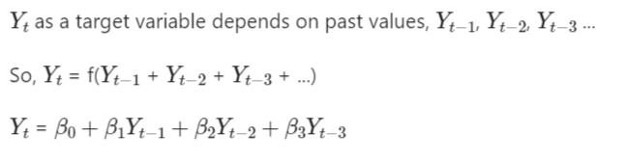

#### 2.3.3 Integrated (I):

Enables the time series to become stationary by separating the raw observations (i.e., data values are replaced by the difference between the data values and the previous values).

#### 2.3.4 Moving average (MA):

Incorporates the relationship between a residual error from a moving average model applied to lagged observations and an observation.

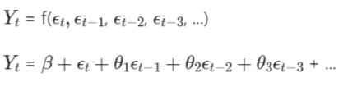

#### 2.3.5 ARIMA Parameters

Each component in ARIMA functions as a parameter with a standard notation. For ARIMA models, a standard notation would be ARIMA with p, d, and q, where integer values substitute for the parameters to indicate the type of ARIMA model used. The parameters can be defined as:

* p: the number of lag observations in the model; also known as the lag order.
* d: the number of times that the raw observations are differenced; also known as the degree of difference.
* q: the size of the moving average window; also known as the order of the moving average.

In a linear regression model, for example, the number and type of terms are included. A 0 value, which can be used as a parameter, would mean that a particular component should not be used in the model. This way, the ARIMA model can be constructed to perform the function of an ARMA model, or even simple AR, I, or MA models.

In this area of the study, the necessary Python libraries, such as NumPy, pandas, matplotlib, and stats-models, were imported to fit the model. The dataset's stationarity was examined utilizing a python block of codes. Following that, several additional lines of code were required to make the dataset stationary using transformation techniques (log, moving average, etc.) because the ARIMA model works best with stationary data. For validation during this study, the Augmented Dickey-Fuller (ADF) test (one of the best and most popular methods to determine if a series is stationary or not), Auto Correlation Function (ACF), and Partial Auto Correlation Function (PACF) were used. After the time series has been stationarized, ACF and PACF plots assist in systematically determining the AR and MA terms that are required.

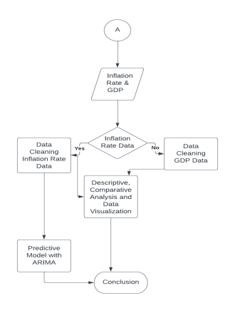

Figure 1: Methodology Flowchart

### RESULTS

#### 3.1 AVERAGE GDP OF SUB-SAHARAN AFRICAN COUNTRIES

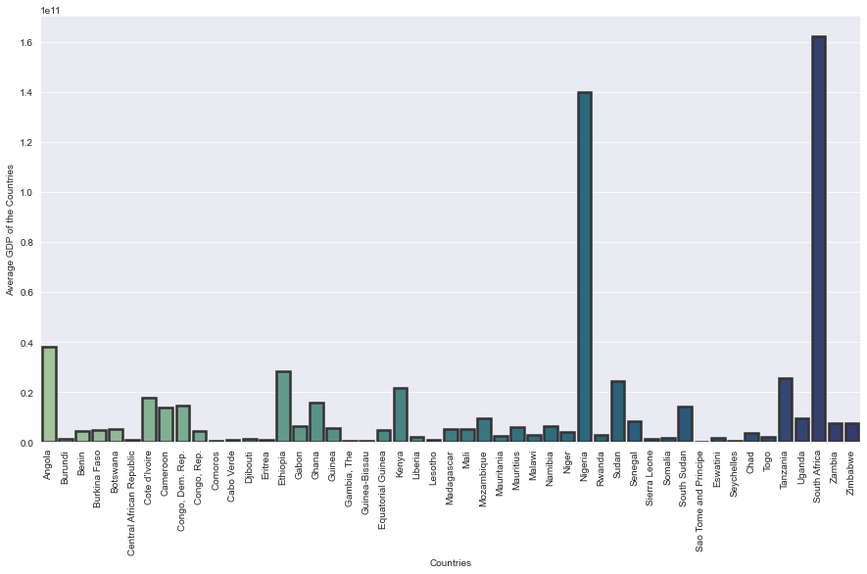

Figure 2: Bar chart showing the average GDP of countries in Sub -Saharan Africa.

From the figure above, the five largest economies of Sub-Saharan Africa are South Africa, Nigeria, Angola, Ethiopia and Tanzania.

#### 3.2 COMPARISON BETWEEN INFLATION RATE AND GDP GROWTH IN THE TOP 5 SSA COUNTRIES (WITH THE HIGHEST GDP)

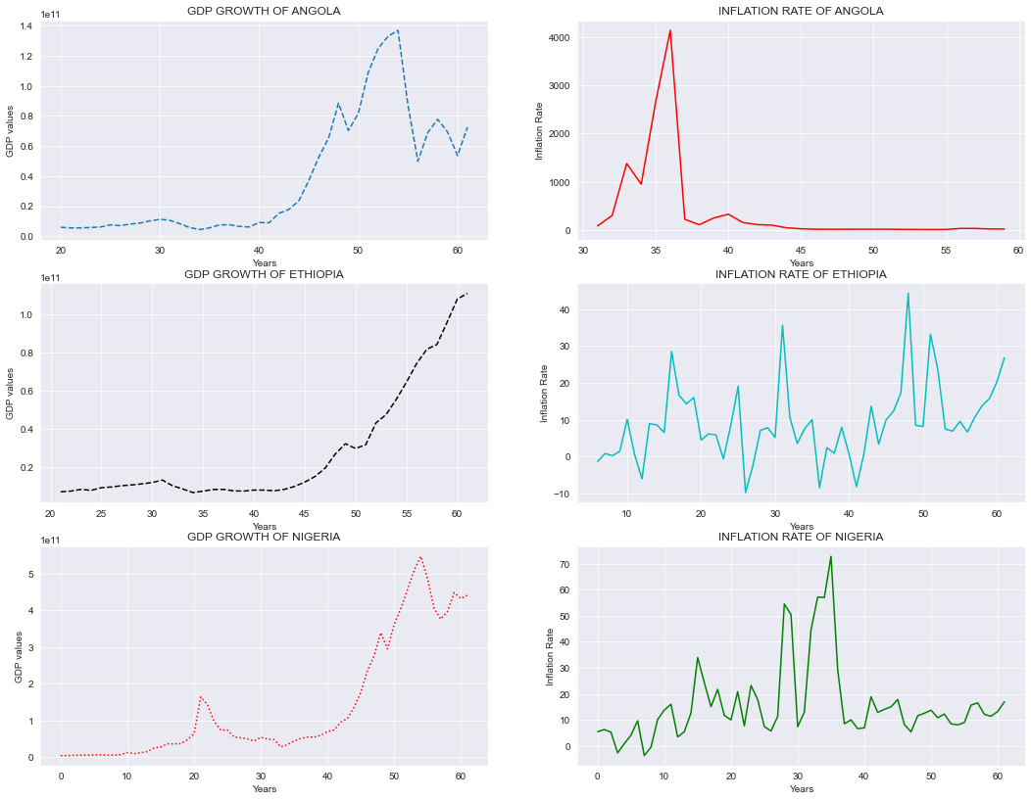

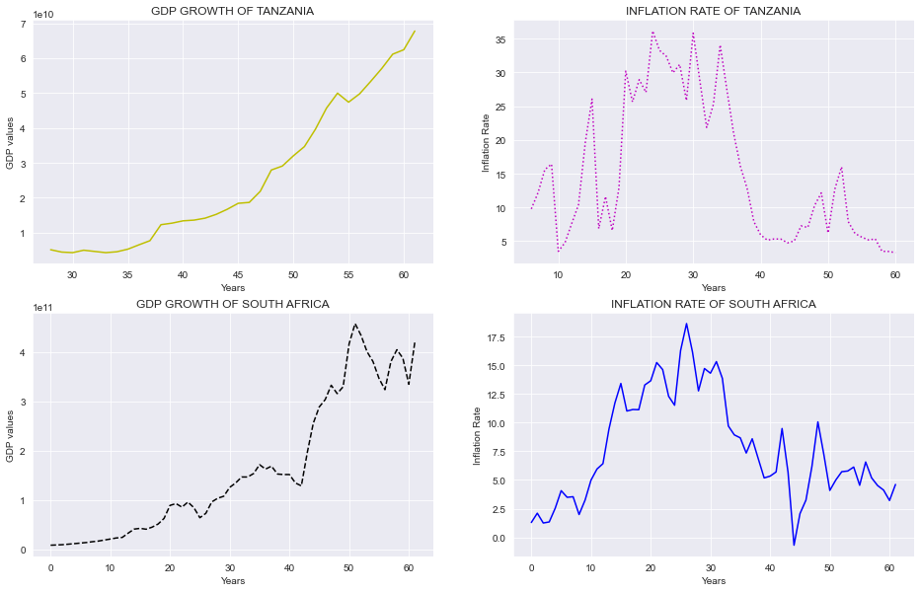Figure 3: Graphs comparing GDP growth and inflation rates of the top 5 countries in Sub -Saharan Africa

#### 3.3 REGRESSION ANALYSIS

#### 3.3.1 AUGMENTED DICKEY-FULLER (ADF) TEST

ADF Statistic: -4.145364, p-value: 0.000814

#### 3.3.2 AUTO CORRELATION FUNCTION (ACF)

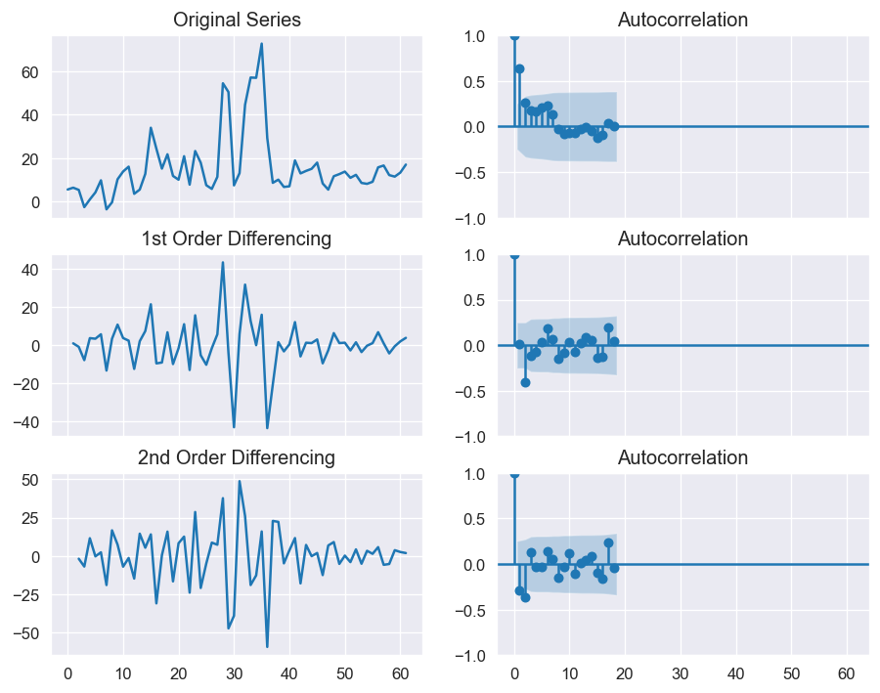

Figure 4: ACF plots for the regression model.

#### 3.3.3 PARTIAL AUTO CORRELATION FUNCTION (PACF)

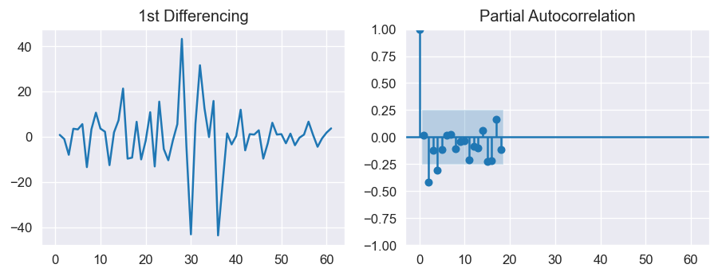

Figure 5: PACF plot of 1st differenced series

#### 3.3.4 ORDER OF THE MOVING AVERAGE

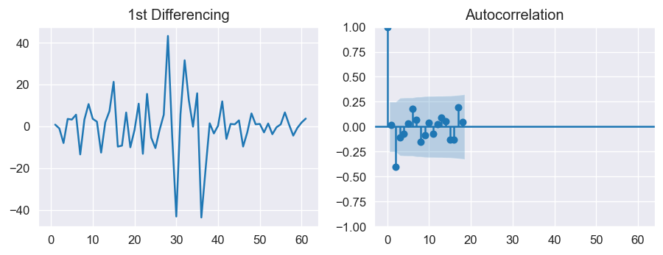

Figure 6: Plot showing the order of the MA term (q)

#### 3.3.5 ARIMA MODEL

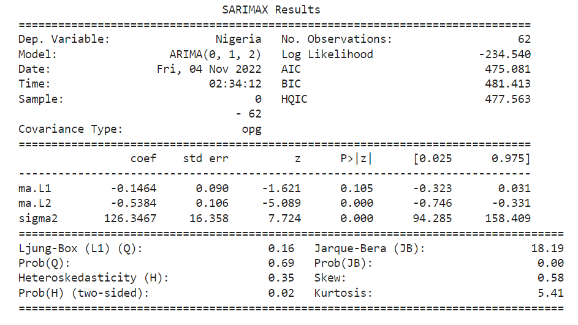

Table 1: Summary of results for the ARIMA model

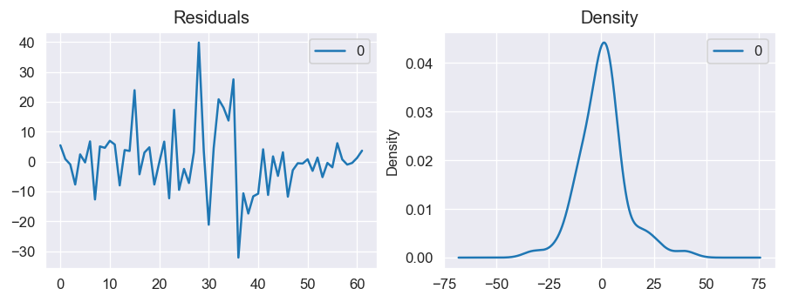

Figure 7: Plot of residual errors

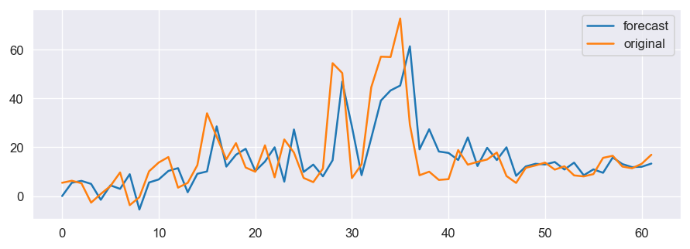

Figure 8: Plot of prediction model: Actual vs Fitted(forecast)

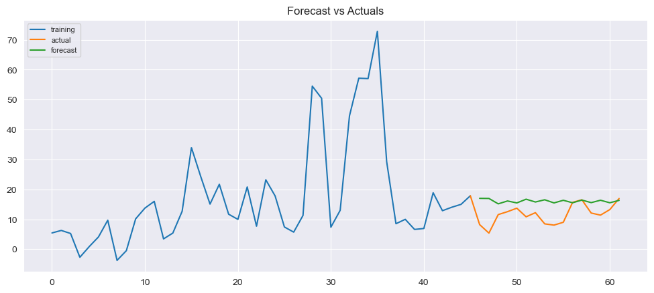

Figure 9: Plot of ARIMA model showing the forecast

### DISCUSSIONS AND CONCLUSION

#### 4.1 DISCUSSIONS

This project's main focus was on the relationship between inflation and economic growth, as well as the causal relationship between inflation and economic growth (using GDP as an index). The countries all had their worst-hit of inflation rates at different times; Angola between 1990 and 2000, Ethiopia between 2000 and 2010, Nigeria between 1990 and 2000, Tanzania between 1980 and 1990, and South Africa between 1980 and 1990.

An article published by the International Monetary Fund (IMF, 2013) stated that the differences in inflation across these African countries can be explained by the difference in monetary policy regimes and other macroeconomic policies pursued. For instance, countries in the CFA zone have a common currency, the CFA franc, which is pegged to the Euro (IMF, 2013). Monetary policy in the region is conducted by the regional central banks (Banque des États de l'Afrique Centrale/Bank of the Central African States (BEAC) and Banque Centrale des États de l'Afrique de l'Ouest/Central Bank of the West African States (BCEAO3)) with a fixed exchange regime in order to keep inflation low (IMF, 2005, 2009). Angola for instance despite the effects of the civil war, had minimum levels of GDP growth in the 1990s – 2000s, the hyperinflation that occurred was mostly due to a budget trap created by the government’s exchange rate policy. The official exchange rate was kept artificially at rather low levels.

GDP growth experiences have also been different across African countries. Starting from the early 2000s, countries like Angola, Ethiopia, Nigeria, South Africa and Tanzania had a higher average growth rate of GDP in the SSA region, while their inflation rates fluctuated continually. The hyperinflation periods of these countries are all characterized by almost zero GDP growth and an occasional shrinking economy. As Figure 3 shows, the way inflation and economic growth relate seems to vary from country to country. Although starting from the 2000s, Angola, Ethiopia, Nigeria, South Africa and Tanzania all had massive GDP growths, inflation rates are moderate in South Africa, Tanzania and Nigeria while Angola and Ethiopia have higher inflation rates. However, in general, figure 3 seems to indicate that low/moderate inflation is associated with higher economic growth while high inflation and hyperinflation are associated with low growth. It can also be observed that on average, the countries with higher GDP growth had a lesser rate of inflation.

#### 4.2 CONCLUSION

It is majorly observed from this study that inflation rates and GDP growth are negatively correlated over a long period, although the negative impact on the economy is temporary. The ARIMA model has shown that inflation is one of the macroeconomic variables that affect GDP growth and can exert a negative impact on economic growth for all countries in the sample. Therefore, inflation can be used to predict economic growth for all countries in the sample. Nowadays inflation in Sub-Saharan African countries is increasing. The model has shown that inflation was negatively and significantly related to economic growth, but at low levels can be positively correlated to economic growth.

### REFERENCES

Abdullah, Ali & Syed, Mohammad & Khan, Ahmad. (2022). The relationship between inflation and GDP with reference to an oil-based economy. International Journal of Multidisciplinary Research and Growth Evaluation. 03. 375-380. 10.54660/anfo.2022.3.1.21.

Anochiwa, L. I., & Maduka, A. (2015). Inflation and economic growth in Nigeria: empirical evidence? Journal of Economics and Sustainable Development, 6(20), 113-121. Retrieved from <https://www.iiste.org/Journals/index.php/JEDS/article/view/26596/27244>.

Ghosh A, Phillips S. (1998). Warning: Inflation may be harmful to your growth. IMF Working Papers.; 45:4.

International Monetary Fund (2005), “Gabon: First Review under the Stand-by ArrangementStaff Report”, IMF Country Report No. 05/3, January 2005

International Monetary Fund (2009), “Republic of Congo: Staff Report for the 2013 Article IV consultation”, IMF Country Report No. 09/74, February 2009

International Monetary Fund (2013), “Republic of Congo: Staff Report for the 2013 Article IV consultation”, IMF Country Report No. 13/282, September 2013

Mamo, F. T. (2012). Economic growth and inflation: A panel data analysis (Published Master Thesis Submitted Södertörns University, Department of Social Sciences, Economics). Retrieved from <http://sh.diva-portal.org/smash/get/diva2:576024/FULLTEXT01.pdf>

Munir, Qaiser & Mansur, Kasim. (2009). Non-Linearity between Inflation Rate and GDP Growth in Malaysia. Economics Bulletin. 29. 1555-1569.

Ndoricimpa, Arcade. (2017), Threshold Effects of Inflation on Economic Growth in Africa: Evidence from a Dynamic Panel Threshold Regression Approach, Working Paper Series N° 249, African Development Bank, Abidjan, Côte d’Ivoire.

Paul S, Kearney C, Chowdhury K. (1997). Inflation and economic growth: a multi-country empirical analysis. Applied Economics. 29:1387-1301.

Sarel M. (1997). Nonlinear effects of inflation on economic growth. IMF Working Staff Papers. 43(1):199-215.

Umaru, A., & Zubairu, A. A. (2012). Effect of inflation on the growth and development of the Nigerian economy (an empirical analysis). International Journal of Business and Social Science, 3(10), 183-191.

### APPENDIX

#### LIST OF FIGURES AND TABLES

Figure 1: Methodology Flowchart

Figure 2: Bar chart showing the average GDP of countries in Sub -Saharan Africa.

Figure 3: Graphs comparing GDP growth and inflation rates of the top 5 countries in Sub -Saharan Africa

Figure 4: ACF plots for the regression model.

Figure 5: PACF plot of 1st differenced series

Figure 6: Plot showing the order of the MA term (q)

Table 1: Summary of results for the ARIMA model

Figure 7: Plot of residual errors

Figure 8: Plot of prediction model: Actual vs Fitted(forecast)

Figure 9: Plot of ARIMA model showing the forecast